Assignment 2

2. PART I: Biological Neural Network & Artificial Neural Network (30 Points)
Question 1.1: Describe (including images for illustration) the human biological neural network and how it works
  - The human biological Neural network:
The human biological neural network composed of billions of neurons that work together to process information enable sensory perception, and control bodily functions. Also known as the nervous system. It’s the most complex structure in the known universal. It is responsible for all our actions, including thinking, feeling, moving, and sensing our environment.
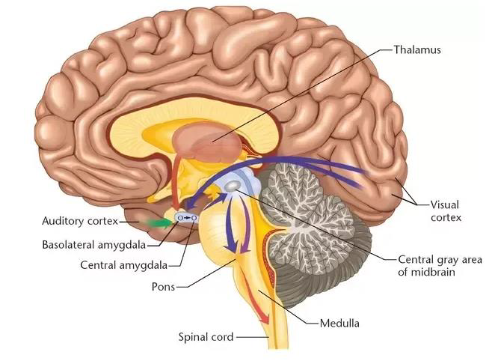

Here's a breakdown of its key components and how they work together:
- Neurons:
- The basic building blocks of the neuron system
- Estimated 100 billion neurons in the human brain alone.
- Each neuron has a cell body, dendrites (which receive signals), and an axon (which sends signals).
Human Neuron (Source: by Bruce Blaus, is licensed under CC BY 3.0)

- Synapses:
- The Synapses are junctions where neurons transmit information. It’s allowed neurons to connect and form complex networks.
- The Synapses helps integrate sensory, chemical messengers called neurotransmitters bridge the gap between neurons.
- The strength of these connections can change support over time, enabling learning and memory.

- Actions potential:
- Neurons generate action potentials to transmit information throughout the body.
- Electrical signals that travel along a neuron's axon.
- Triggered by the combined input signals received at the dendrites.
- Follow an all-or-nothing principle: the signal either reaches the threshold and fires or does not.
- Nervous system organization:
- The Central Nervous System (CNS) consists of the brain and spinal cord, processing sensory data, generating thoughts, and sending motor commands, while coordinating reflexes and communication throughout the body.
- The Peripheral Nervous System (PNS) includes neurons outside the CNS, managing voluntary movements via the somatic system and involuntary functions via the autonomic system.
- Autonomic nervous system (controls involuntary functions like heart rate and digestion).
- Neurons transmit electrical signals called action potentials through synapses, forming neural networks. Sensory information is gathered by neurons in the PNS, processed in the CNS, and responses are generated. Local and inter-regional circuits coordinate movement, sensation, and complex behaviors across the entire brain-body system.

In conclusion, Neurons, synapses, and action potentials work together in the nervous system, allowing communication between the brain and body. The CNS and PNS work together to process sensory information, generate responses, and manage both voluntary and involuntary functions. This coordination enables learning, movement, sensation, and overall body functions and regulation effectively.

Question 1.2: Describe (including images for illustration) the McCulloch-Pitt neuron model, a.k.a. Threshold Logic Unit, that is considered as the simplest neural network and how it works.

1.2 The McCulloch-Pitt neuron model

The McCulloch-Pitts neuron model, also known as the using inputs, weights, and a threshold activation function to produce a binary output. It performs basic biological neurons, modeling, and logical operations, foundation for artificial neural networks.

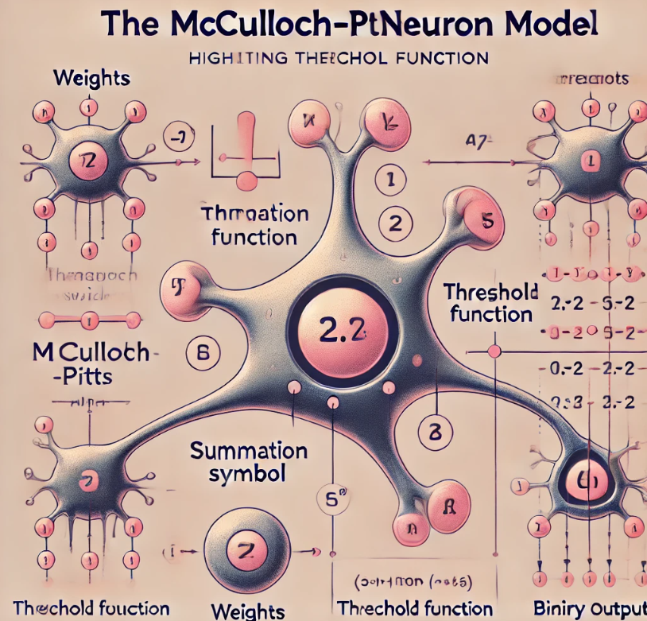

The diagram shows the inputs, weights, summation symbol (Σ), threshold function, and the binary output, emphasizing the activation threshold concept.
The McCulloch-Pitts neuron, introduced by Warren McCulloch and Walter Pitts in 1943, is a simplified mathematical model, and fundamental working of a biological neuron.

Here's a breakdown of its structure and function as following.

Structure:

Inputs: Receives multiple binary inputs (0 or 1), representing signals from other neurons.
Weights: Each input has an associated weight, signifying its influence on the final output.
Summation Functions: Incoming signals are multiplied by their weights and summed together.
Threshold Function: The summed value is compared to a predetermined threshold. If the values exceed the threshold the neuron activates. Otherwise, it remains inactive.
Outputs: The binary outputs (1 or 0) representing the neuron’s decision in the simplest form.

Function:
- Each input signal carries a value (0 or 1) and is multiplied by its corresponding weight.
- These weighted values are summed together.
- If the sum surpasses the set threshold, the neuron "fires," producing an output of 1.
- Conversely, if the sum falls below the threshold, the neuron stays inactive, resulting in an output of 0.

Think of it as a simple decision-making unit:
- Imagine inputs representing environmental factors like temperature and humidity.
- Weights reflect the importance of each factor for an insect's survival.
- The threshold represents the minimum safe combined value.
- If the weighted sum exceeds the threshold (indicating danger), the insect chooses to seek shelter (output of 1).

Limitations:
- Binary inputs and outputs restrict the model's complexity.
- It cannot learn or adapt, limiting real-world applications.

Importance:
- Despite limitations, the McCulloch-Pitts model paved the way for more advanced neural network architectures.
- It inspired advancements in artificial intelligence and machine learning by showing how computational models could mimic aspects of neural processing.
- Key Takeaways:

Key Takeaways:
- The McCulloch-Pitts neuron model, though simple, marked a major step in understanding how neurons might compute information.
- Despite its limited capabilities, it laid the foundation for future neural network developments.
- Its legacy is in inspiring the exploration of more complex and powerful models in artificial intelligence.

Question 1.3: Discuss (including images for illustration) how the pioneers in the AI field did imitate the human biological brain system to conceive the first artificial neural networks.

1.3 The pioneers in the AI field
The pioneers in AI were mathematicians and researchers who developed foundational theories, algorithms, and models to simulate human intelligence, understanding the brain's learning, reasoning, and problem-solving abilities, laying the groundwork for neural networks and machine learning.

The development of artificial neural networks was inspired by the human brain’s ability to process information, learn, and adapt. The pioneers in artificial intelligence, such as Warren McCulloch, Walter Pitts, Frank Rosenblatt, John McCarthy, Marvin Minsky, and others, aimed to replicate the functioning of biological neurons to create machines that could think and learn.

McCulloch-Pitts Neuron Model (1943): It was inspired by how real neurons work. It set the foundation for artificial neural networks. Picture simple connected circles, where each one takes in signals and gives an output. These 'artificial neurons' copied the basic structure and function of real brain cells.

1949: Hebbian Learning: Donald Hebb suggested that connections between neurons get stronger the more they are used. This idea, called Hebbian Learning, became crucial for designing networks that could learn and adapt from experience.
1957: Perceptron: Frank Rosenblatt created the first true neural network, marking a key moment in AI history. Image multiple layers of connected McCulloch-Pitts neurons, inspired by the brain's structure. The Perceptron could learn basic patterns by adjusting the strengths of its connections, imitating how the brain learns.

Key Inspirations from the Brain:
- Interconnected Neurons: Neural networks mirror the brain's structure, with interconnected processing units communicating through weighted connections.
- Learning and Adaptation: Inspired by Hebbian learning, early networks adjusted connections based on experience, mimicking the brain's learning process.
- Parallel Processing: Like the brain, neural networks distribute computations across multiple units, making them faster and more efficient.
Challenges and Advancements:
- Limitations: Early models like Perceptron struggled with complex tasks and lacked the brain's full complexity.
- Training Difficulties: Training these models requires significant resources and specific data formats.
Despite these challenges, pioneers achieving, leading to breakthroughs in artificial intelligence and neural network development.
Challenges and Advancements:

- Limitations: Early models, like the Perceptron, struggled with complex tasks and did not capture the full complexity of the brain.
- Training Difficulties: Training these models requires significant resources and specific data formats.
Despite these challenges, pioneers persevered, leading to important breakthroughs.
1974: Backpropagation Algorithm: Paul Werbos introduced a groundbreaking method for training complex networks. Image errors moving backward through the network, adjusting connection strengths to improve future performance to the brain learns from feedback.
1982: Hopfield Network: John Hopfield developed created recurrent neural network, inspired by the brain's associative memory. Image the network storing and retrieving patterns to how we recall memories based on connections.
Legacy and the Future:
Though not perfect copies of the brain, early models paved the way for advanced deep learning systems, like CNNs and RNNs, which now power image recognition, language translation, and self-driving cars.
The journey continues as researchers explore neuroscience, aiming to create advanced AI systems inspired by biology. Although we may never fully replicate the brain, early pioneers inspire ever-more intelligent machines.

3. PART II: Linear Algebra for Deep Learning: Matrices (25 Points)

